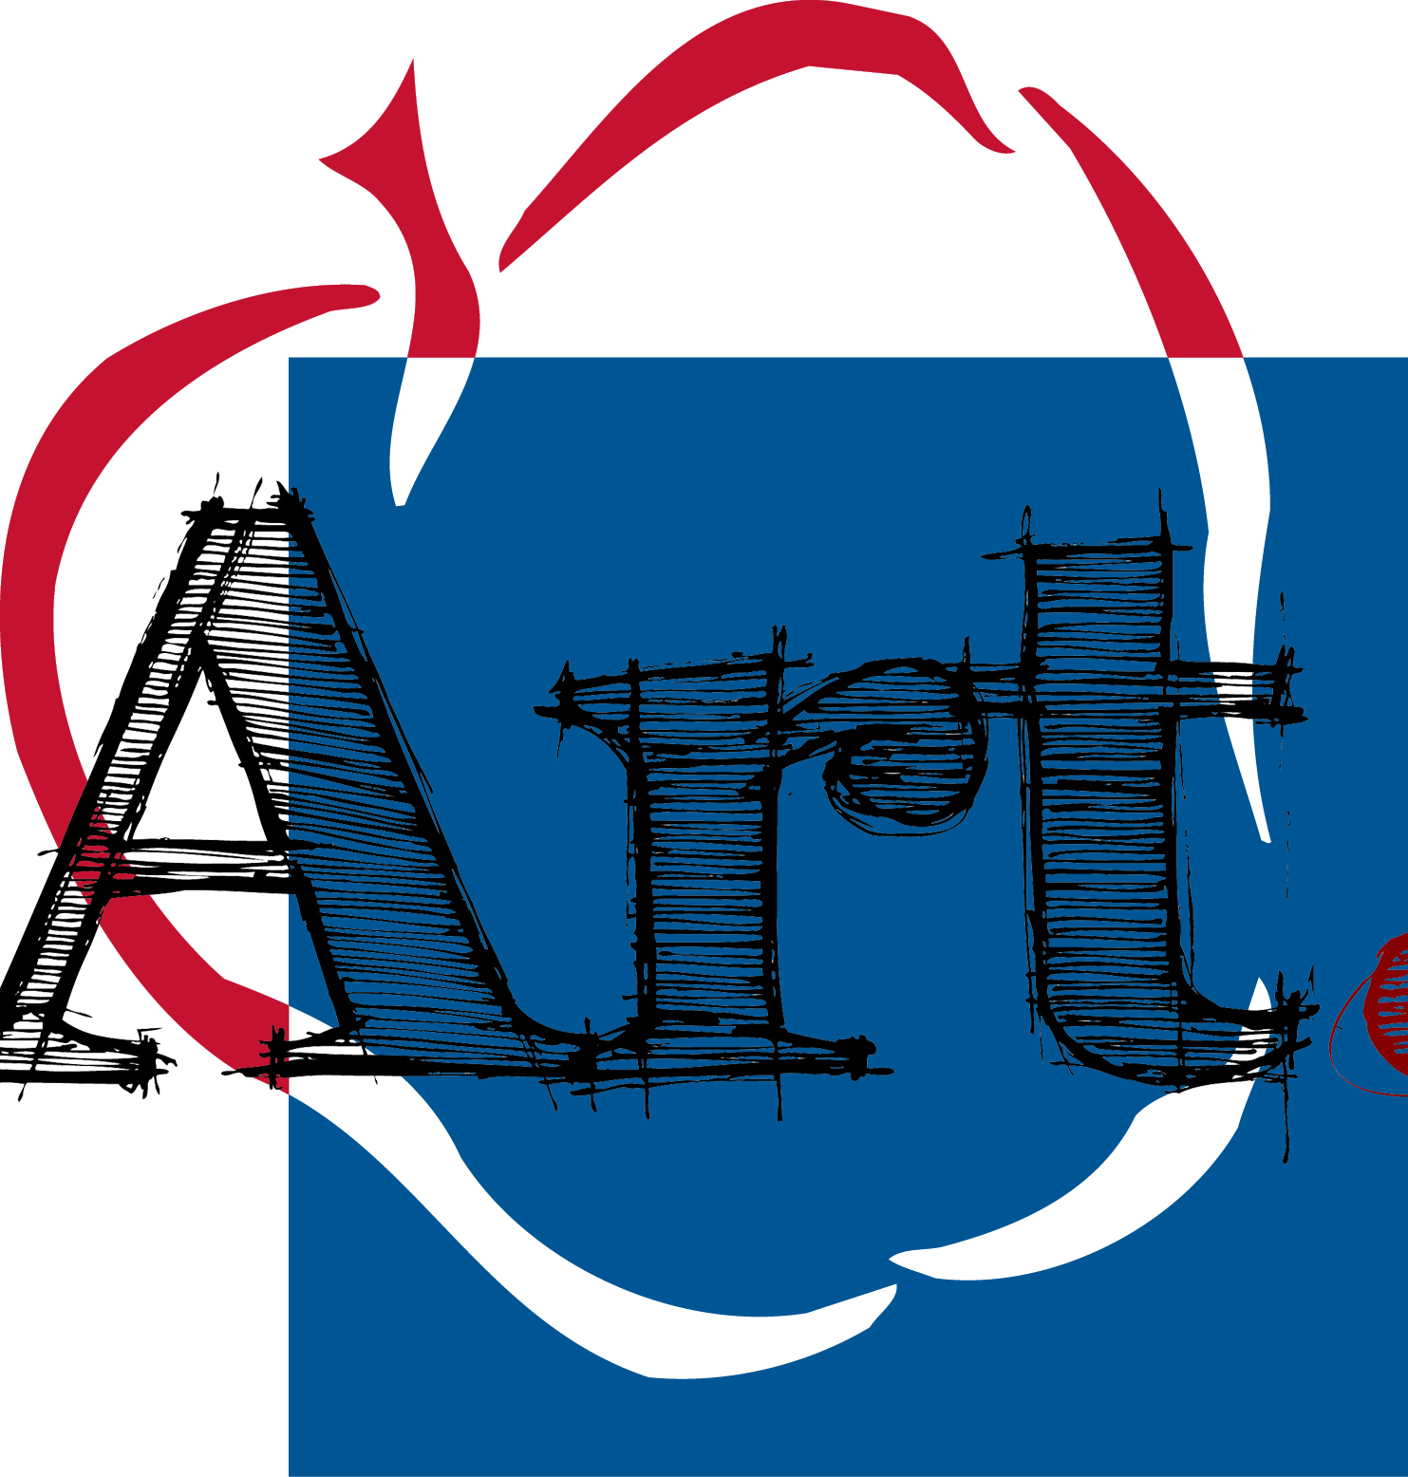
Anne Arundel County
Public Schools
Middle School Visual Arts Syllabus

Digital Palette, 7th and 8th Grade
Teacher: Nicole Drummond
Email: ndrummond@aacps.org, Phone: (410) 222 6493
Re-teaching/Reassessment: Tuesdays 3:05-4:00, Room 122
Class Website: http://corkranart.weebly.com
Course Overview & Sequence
In the Digital Palette: Computer Graphics, Middle School Level course, students will develop experiences in art fundamentals focused on the principles of design, digital imaging, and be introduced to computer graphics programs, digital vocabulary, and basic concepts in electronic design. Focus is on creating artwork in various formats, including print and possibly the Web. Projects will be created using integrated software such as Photoshop Elements, PowerPoint, and other programs. Ethical and current technological issues will be addressed. Advertising, package design, and fine arts projects will be some of the areas explored. Individual experience will serve as the basis for solving visual arts problems based on personal criteria. Students will understand and articulate visual arts vocabulary
Materials needed for class:

- Spiral notebook or composition notebook
- Pencil, eraser
- All art supplies will be provided to work with during class, but it may be beneficial to have a flash drive
Course Content and Standards:
All visual arts programs in Anne Arundel County are based on standards aligned with and adapted from the National Standards for Visual Arts and the Maryland State Standards for Visual Arts:

- 1.0 Perceiving and Responding: Aesthetic Education: Students will demonstrate the ability to perceive, interpret, and respond to ideas, experiences, and the environment through visual art.
- 2.0 Historical, Cultural, and Social Context: Students will demonstrate an understanding of visual arts as a basic aspect of history and human experience.
- 3.0 Creative Expression and Production: Students will demonstrate the ability to organize knowledge and ideas for expression in the production of art.
- 4.0 Aesthetics and Criticism: Students will demonstrate the ability to identify, analyze, and apply criteria for making visual aesthetic judgments.

For the complete MSDE Visual Arts Standards go to: http://mdk12.org/instruction/curriculum/arts/index.html

Quarter 1:  - Rhythm  - How is rhythm employed to direct attention through an artwork?  - Elements of art Review  - How are the elements of art related to the principles of design? | Quarter 2:  - Balace  - How is balance used to create visual stability in an artwork?  - Repetition/Pattern  - What is the function of pattern in artwork?  - How does repetition effect a composition?
Quarter 3:  - Movement  - How does movement impact an artwork?  - Contrast  - How does contrast influence the impact of the artwork? | Quarter 4:  - Unity/Variety  - Why is unity essential in an artwork?  - How does variety enhance a composition?  - Portfolio Assessment  - How do the principles of design contribute to aesthetic quality of the portfolio?

Standards of Visual Arts Practices:

Students will work with ways to heighten thoughts and expression in their artwork. Knowledge gained from studying other artists and cultures will be applied in solving problems in art. Design skills will be used to solve problems based on observation and life experiences that exemplify personal critical choices. Topics of study are:

- Elements of Art Review: How are the elements of art related to the principles of design?
- Pattern: What is the function of pattern in artwork?
- Repetition: How does repetition effect a composition?
- Rhythm: How is rhythm employed to direct attention through an artwork?
- Movement: How does movement impact an artwork?
- Unity: Why is unity essential in an artwork?
- Variety: How does variety enhance a composition?
- Emphasis: Why is emphasis significant in a composition?
- Contrast: How does contrast influence the impact of the artwork?
- Balance: How is balance used to create visual stability in an artwork?
- Portfolio assessment: How do the principles of design contribute to the aesthetic quality of the portfolio?

Course Grading:
Grades are given to middle school students to document progress toward and mastery of course content, skills, and standards. Teachers shall evaluate student progress to determine the degree of mastery of course content, skills, and standards. The art grade represents a composite of the student’s achievement and performance in daily assignments and assessments. The grade may be derived from objective and subjective teacher evaluations and observations, including the student’s demonstrations of criteria-based skills and techniques in artwork.

Teachers shall record the marking period grades for each student using the following process based upon the final percentage of points earned divided by possible points, shall be calculated to the tenths place and then rounded to a whole number (.5 and higher rounds up), and shall appear on the report card. Your grade in this course will be determined based upon your progress towards mastery of the standards. Specifically, your grade will be calculated using the following weighted categories.

60% Summative Unit Assessments and Projects
Each project will be broken up into five separate grades, as follows:
- Creativity
- Craftsmanship
- Completion
- Creativity
- Composition
40% Classroom Assignments and Quizzes
These will include practice assignments, sketchbook work, readings about artists, reflections, and any other assignments which are not a major art project

Grades are recorded and can be accessed by parents through Power Teacher

The Art teacher uses both formative and summative assessment strategies to monitor student mastery. Students will be assessed on a regular basis; at least 5 assessments are recorded during a marking period. Students are provided the lesson criteria and their artwork should demonstrate mastery knowledge of skills and content. The Art teacher will select and implement an evaluation instrument such as, self-assessment, peer assessment, end of unit assessment, teacher assessment, and/or portfolio assessment, which is appropriate for the lesson taught.
Assessment:
Assignment Descriptions:

1. Summative Unit Assessments and Projects – there will be at least one project per unit. We usually do at least 2 units a marking perod.
2. Classroom Assignments – Practice assignments, readings, sketchbook assignments, and reflections are all under the classroom assignments. Quizzes will sometimes be given at the end of a unit to assess knowledge.
Opportunity for Mastery:
Per AACPS regulation, students may redo up to three assessments and/or assignments each quarter. Students are encouraged, but not required, to participate in teacher-led re-teaching. All redo items must be completed within ten days of receiving the original grade and may only be redone one time. The higher of the two grades will be used for calculating the student’s quarter grade. The teacher may choose to have the student redo all of an assessment or assignment or may have student only redo specific items or parts of the work. Students may not redo homework, a multi-part project or assignments completed in the last week of the quarter. However, students may redo parts of a large project, if graded separately by the teacher, with each part counting as a separate redo.
Late Work and Incomplete Assignments:
Students are expected to submit assignments on the date that they are due. Students are expected to complete assignments, in full, to the best of his/her ability and students should take advantage of tutoring and re-teaching opportunities so that the student can submit his/her best work. Late assignments are penalized 10% for each day it is late up until five school days (not A/B/C days). After five school days, the assignment becomes a zero and may not be submitted for a grade. Should your student be in danger of failing or not meeting course criteria, you will be notified.

Teachers shall assign a minimum grade of 50% to assignments or assessments for which the student made a good faith effort, as determined by the teacher, to meet the basic requirements. If a student does no work on an assignment or assessment, the teacher shall assign a grade of zero.

When a student is absent, it is the student’s responsibility to get the make-up work. The student will be allotted the same number of days equal to the number of days absent to make-up work.

Recording of Grades and Communication with Parents:

Per AACPS regulation, all grades, with the exception of lengthy assignments such as projects and extended writing assignments, will be entered into Parent Connect within one week of assignment submission. Parents can check Parent Connect regularly to monitor student grades.

Academic Dishonesty:
A student who exhibits academic dishonesty as determined by the teacher and administrator shall receive a zero on the particular assignment in question. Violations of the Academic Integrity Policy and Regulation may result in disciplinary action. Consequences for violations may vary according to the severity of the violation and shall follow the progressive interventions and discipline as outlined in the Student Code of Conduct.

Student’s name ______________________________________________________

Student’s signature __________________________________________________
Parent’s signature __________________________________________________
Preferred method of contact:

____________________

Parent’s e-mail __________________________________________________
Parent’s Phone ______________________________________________________
Donations are always accepted for the following items:
Want to help?
- Baby wipes, Clorox wipes
- Mr. Clean magic erasers
- Pencils, erasers
- Hand soap (Pump)
- Hand sanitizer
- Colored Pencils, hand held sharpeners
Thank you!

