Open your image from the goodies drive (Goodies > Course folders > art > Photo library)
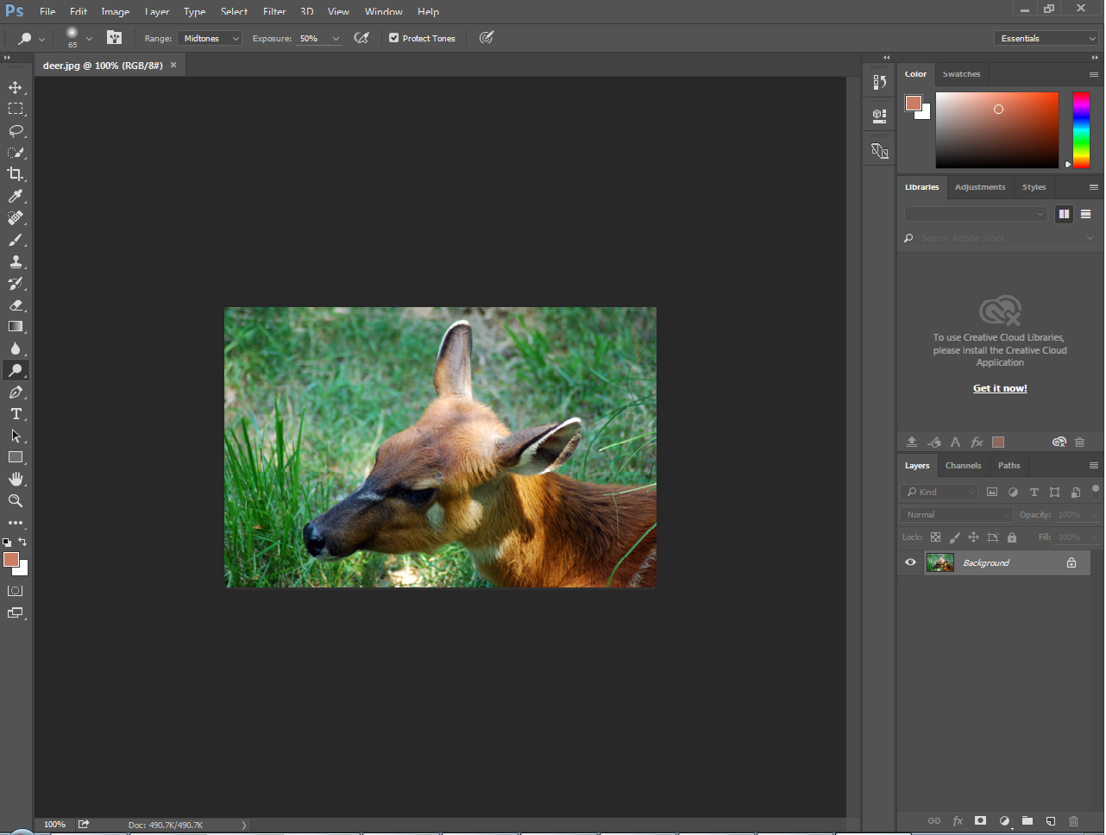

These are your LAYERS, they are your PIECES of your photoshop document.

The button that looks like a post-it note is your new layer button. Click it to create a new layer.

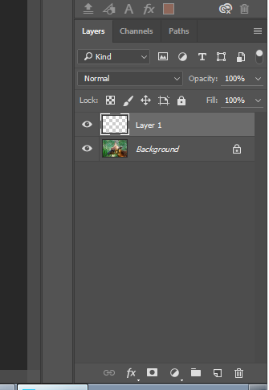
Your layers panel should now look like this.
The background layer (image), and a blank layer above it. This is where we will be creating our image.
DO NOT MAKE ANY EDITS TO THE BACKGROUND LAYER.

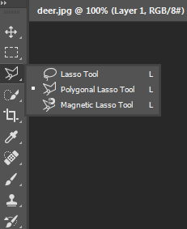
For this project, we will be using the polygonal lasso tool. It is below the lasso tool. Click and hold the lasso tool, then select polygonal lasso.
When switching back and forth between tools, polygonal lasso is L on the keyboard.
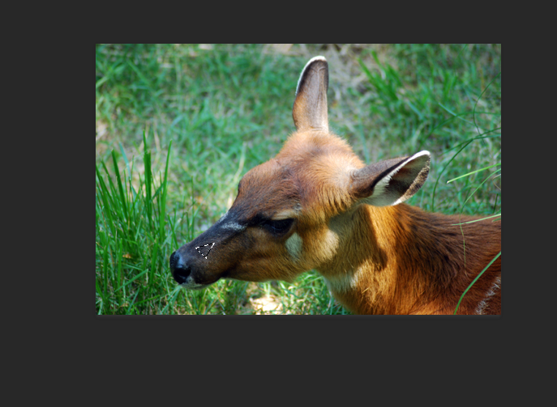
Using the polygonal lasso tool, make a selection on part of your image. When the selection is complete, you will see “dancing ants”. If the selection will not complete, double click. If you mess up and want to erase your selection, hit control D to de-select.
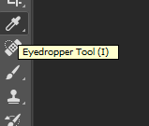
Next use the eyedropper tool (keyboard shortcut, letter i). Select the color inside of the selection you made with the polygonal lasso tool. (Inside of the dancing ants).

The next tool we need is the paint bucket tool (keyboard shortcut, letter G). Click inside of the selection you made. The area will fill with the color you selected. Be sure you are on layer one and not on the background layer.
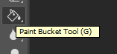

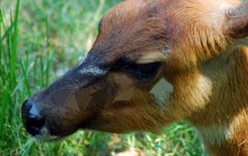
Repeat the process a few times, using L for the polygonal lasso tool to select an area, i for the eyedropper tool to select the color, and G for the paint bucket to fill the area. You will start to see small sections of color. Each time you select with polygonal lasso, you need to select a new color. These selections should be SMALL.

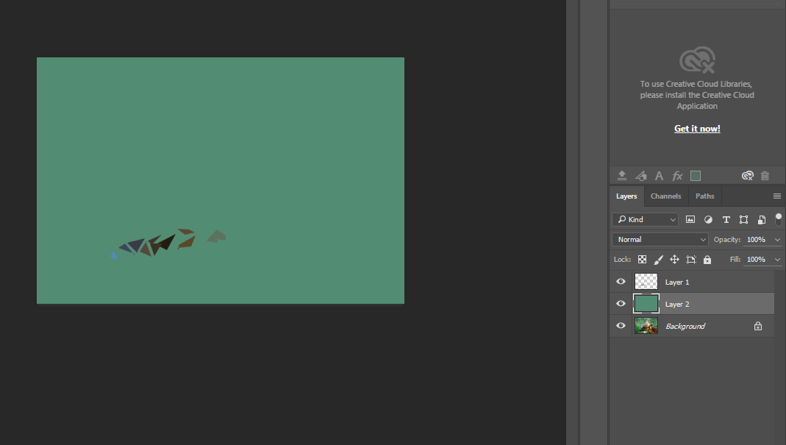
Later, you can check your progress by adding a new layer with a solid color in between your layer with shapes and the image layer. You can “hide” the layer by clicking on the eyeball next to it.
Finished student work examples:
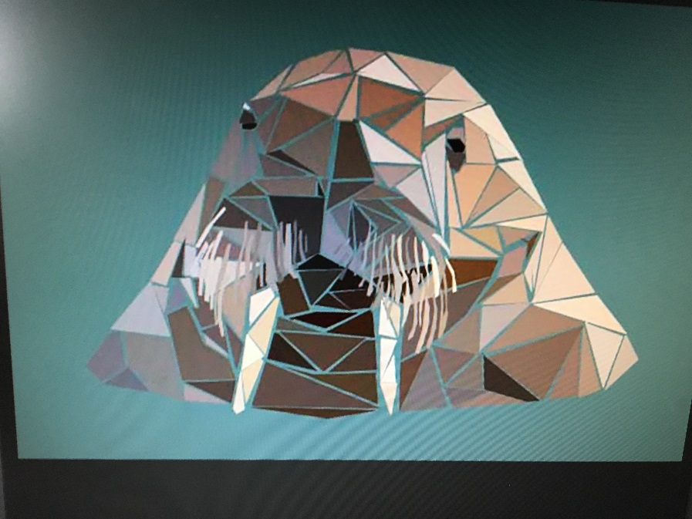
Notice the detail with the whiskers
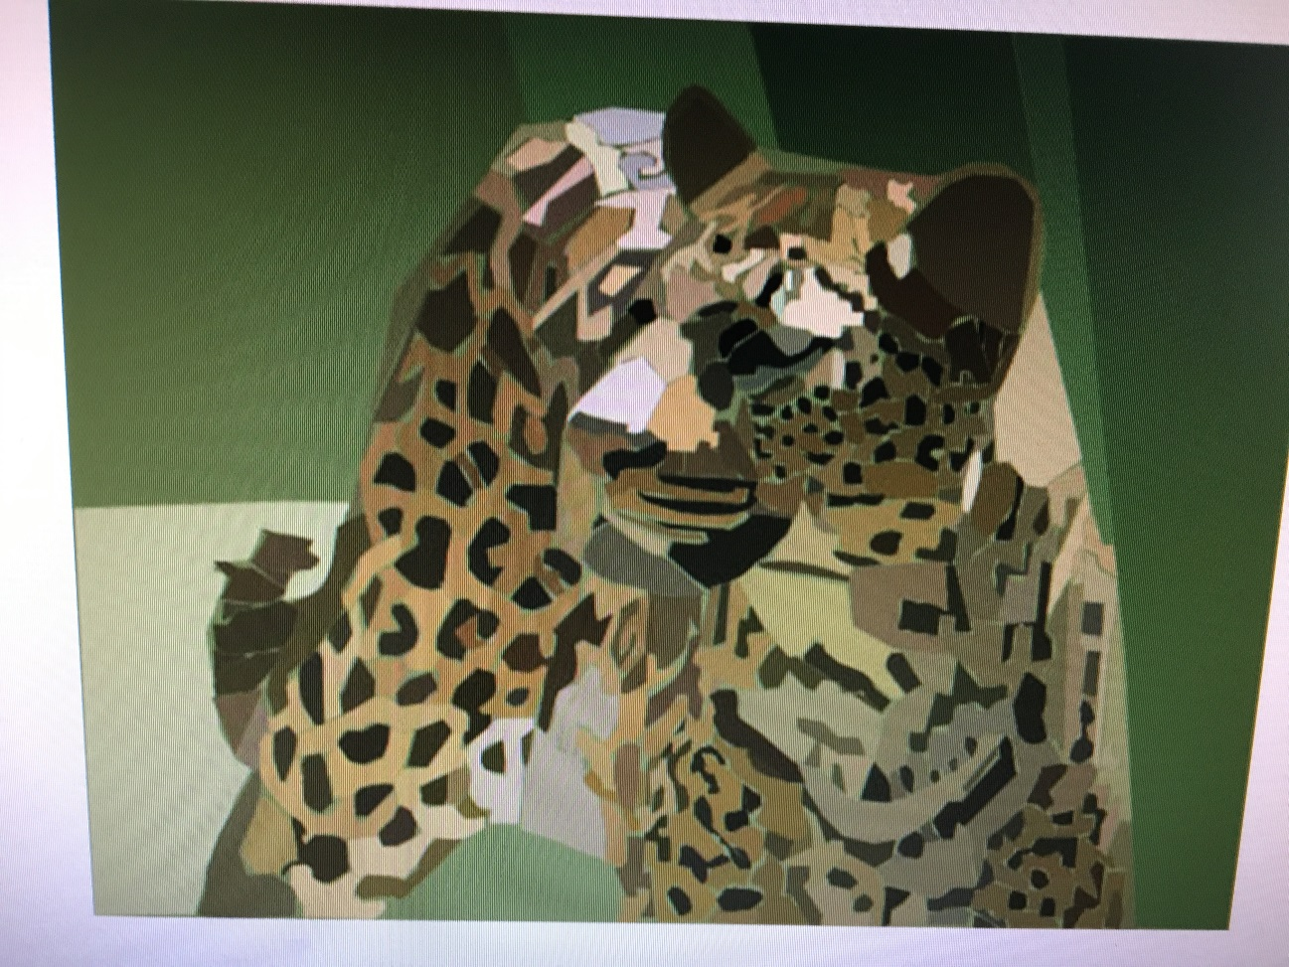
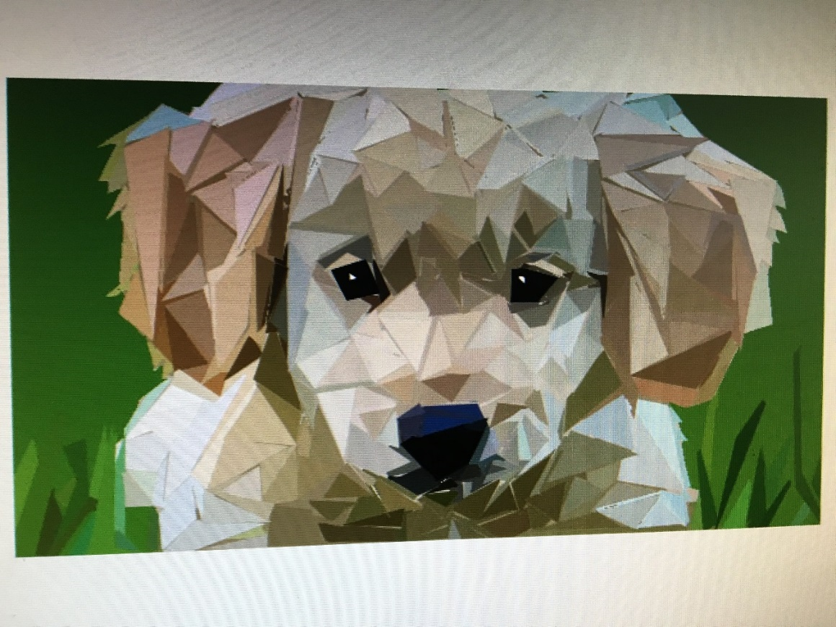

Notice the blades of grass for added detail and to add a background!

