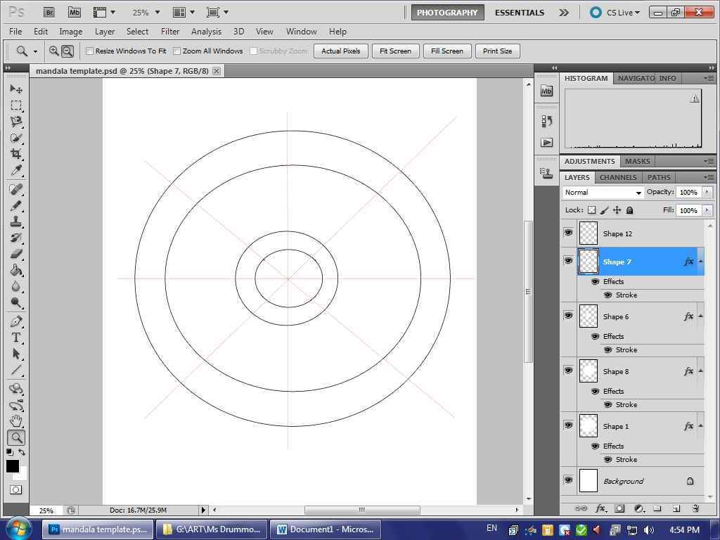

All of the layers to make up the mandala have been placed into a group. Do not edit these layers. Create a new layer for whatever you want to add.

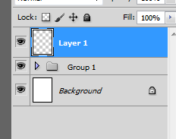 

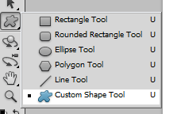

Click and hold and select custom shape tool.

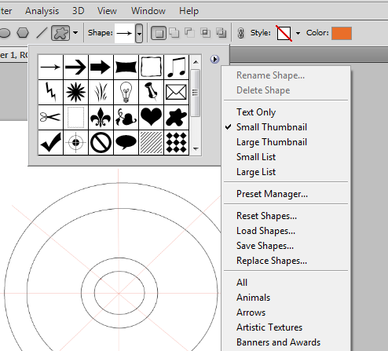

Go to the top and click the right arrow

This will bring down a drop down of options of shapes

Click the small arrow to the right to bring down another drop down of options

In this drop down, click all. This will load all of the possible shapes to use

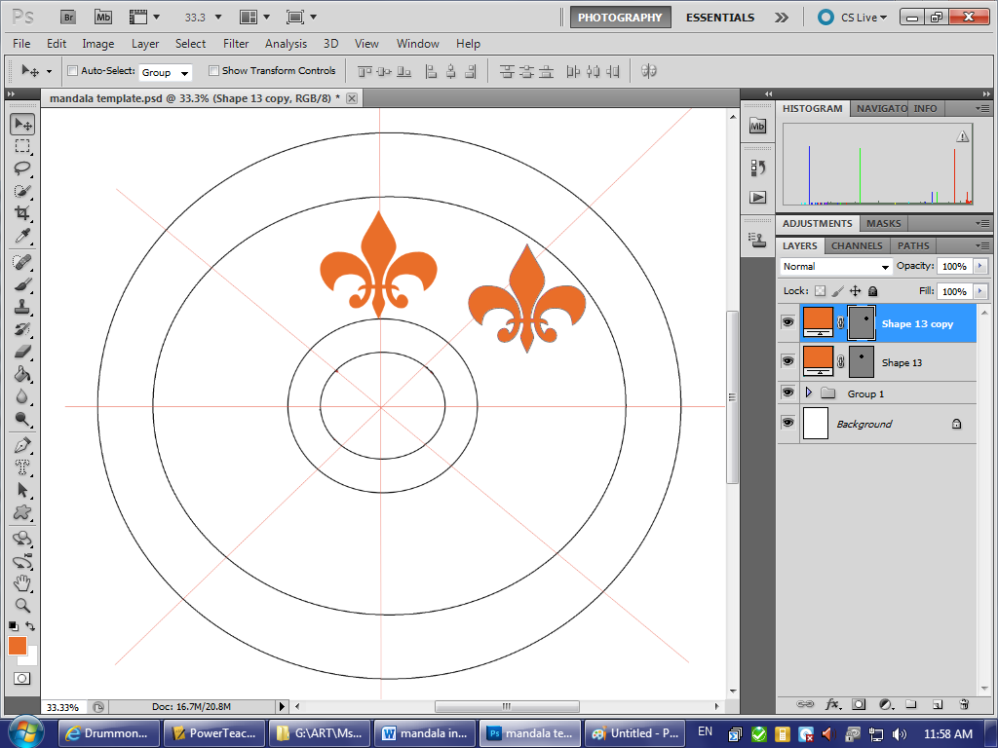

Make your shape of your choice.

To copy it, right click the shape layer, click duplicate. Then use the move tool to select your copied shape. (It will be directly on top of the first one you made.)

You can place the shapes on the lines, or in the individual “triangles”.

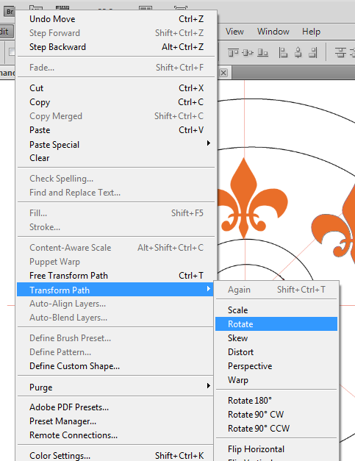 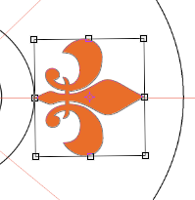

Right click, click edit, select transform path, then rotate

This will place a box around your image and allow you to rotate it



When you are done, you need to top right corner. Click on the check mark in the top right corner.

To add EFFECTS to your shapes, right click the shape layer and click blending options. The following menu will appear.

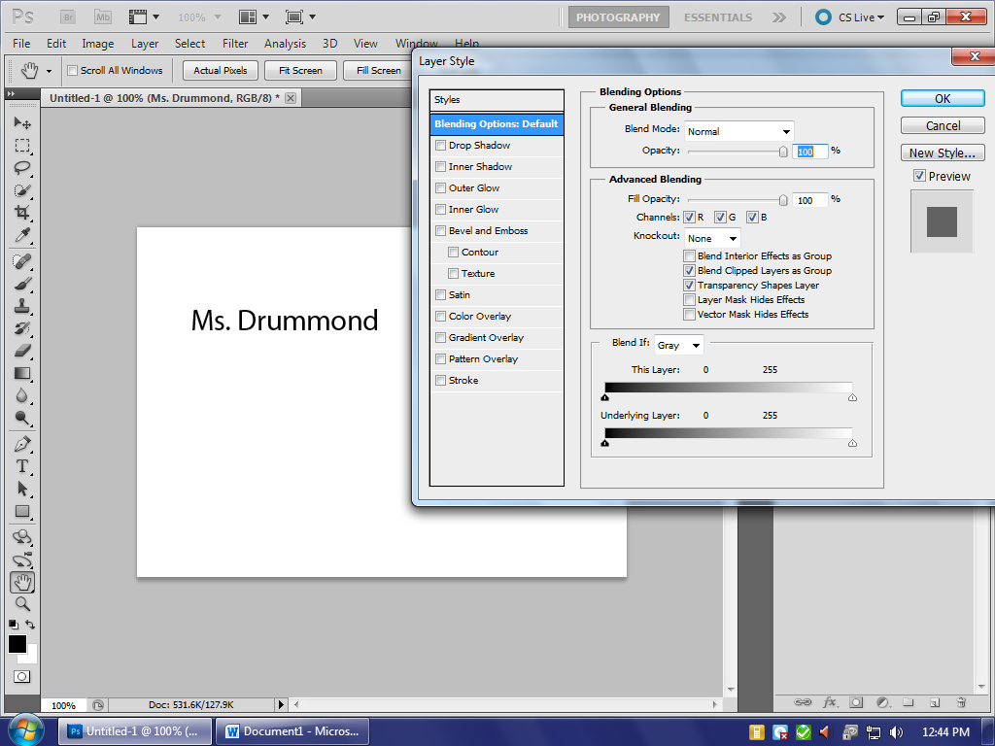

Click the options on the left to turn them on and off. You can *edit* each of these options as well, make sure the the option is selected (is blue)—click on the words (drop shadow, inner glow, etc), not the check mark to edit.

Continue these steps with different shapes and colors to create your mandala.