While Reading:
- Number the paragraphs
- Circle vocab words/tools
- Underline how the tool is used
- BOX answers to your questions
- Write in the margins—questions, symbols, etc

About selections
A selection is an area of a photo that you define. When you create a selection, the area is editable (for example, you can lighten one part of a photo without affecting the rest). You can make a selection with either a selection tool or a selection command. A selection border, which you can hide, surrounds the selection. You can change, copy, or delete pixels inside the selection border, but you can’t touch areas outside the selection border until you deselect the selection.
Adobe Photoshop Elements provides selection tools for different kinds of selections. For example, the Elliptical Marquee tool selects circular and elliptical areas, and the Magic Wand tool can select an area of similar colors with one click. More complex selections can be made with one of the Lasso tools. You can even smooth the edges of a selection with feathering and anti-aliasing.
Note:
Selections are limited to the active layer—to make changes to all layers at once, you first need to flatten the image.
The selection tools are located in the Tools panel, which is located, by default, on the left side of your screen.

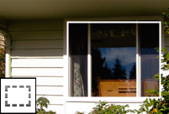
Rectangular Marquee tool: Draws square or rectangular selection borders.

Elliptical Marquee tool: Draws round or elliptical selection borders.

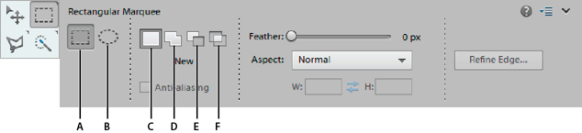
The Rectangular Marquee tool draws square or rectangular selection borders, and the Elliptical Marquee tool draws round or elliptical selection borders.
A. Rectangular Marquee tool B. Elliptical Marquee tool C. New selection D. Add to selection E. Subtract from selection F. Intersect with selection
- Select the Rectangular Marquee tool (A) or the Elliptical Marquee tool (B) in the toolbox.
- (Optional) Set marquee tool options in the Tool Options bar:
  - Specify whether to create a new selection (C), add to a selection (D), subtract from a selection (E), or select an area intersected by other selections (F).
  - To soften the selection border so that it blends into the area outside the selection, enter a Feather value.
- Drag over the area you want to select. Hold down the Shift key as you drag to constrain the selection marquee to a square or circle.
Note: To drag a marquee from the center, hold down Alt (Windows)
Note: To reposition a marquee tool selection border, hold down the spacebar as you drag with the selection tool. Release the spacebar once the selection border is in the correct area.

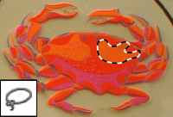
Lasso tool: Draws freehand selection borders, best for precision.

Polygonal Lasso tool: Draws multiple straight-edged segments of a selection border.

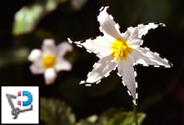
Magnetic Lasso tool: Draws a selection border that automatically snaps to edges when you drag over in the photo.

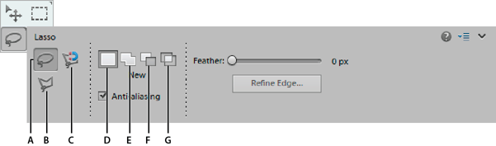

The Lasso tool draws freehand selection borders. This tool lets you make very precise selections.
- Lasso tool B. Polygonal Lasso tool C. Magnetic Lasso tool D. New selection E. Add to selection F. Subtract from selection G. Intersect with selection
The Polygonal Lasso tool draws straight-edged segments of a selection border. You can create as many segments as you need to draw a selection border.
The Magnetic Lasso tool draws a selection border that automatically snaps to the edges of objects you drag over in the photo. This makes it easy to draw precise selection borders. The Magnetic Lasso tool is useful for quickly selecting objects with complex edges set against high-contrast backgrounds.
The Magic Wand tool selects pixels within a similar color range with one click. You specify the color range, or tolerance, for the Magic Wand tool’s selection. Use the Magic Wand tool when you have an area of similar colors, like a blue sky.
The Quick Selection tool makes a selection based on color and texture similarity when you click or click-drag the area you want to select. The mark you make doesn’t need to be precise, because the Quick Selection tool automatically and intuitively creates a border.

Magic Wand tool: Selects pixels of similar color with one click

Quick Selection tool: Quickly and automatically makes selection based on color and texture when you click or click-drag an area.
