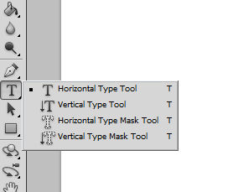
Use the text tool to type. You can type horizontal (normal, left to right) or vertical (up and down).

At the top of your screen you can edit the font, size of the text, and color.

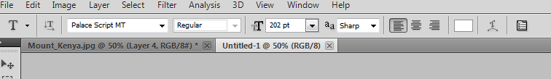

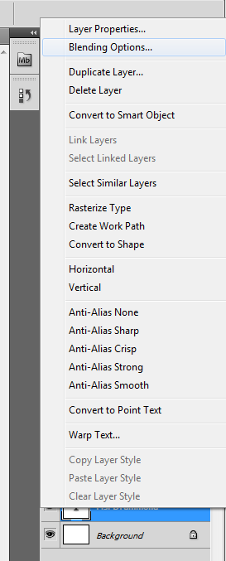
After you type your text in the color and font you want, right click your text layer and hit blending options. This will bring up options such as drop shadow, and many others, like glows, outlines, and textures.

Using the pen tool to add text to a path
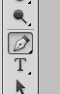
To use the pen tool, click once, click a second time and without letting go drag your mouse to create the arc that you want.
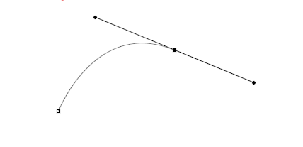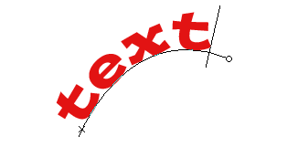

Use the text tool and hover over your arc, a small squiggle will appear next to the arc. You can then type your text and it will form to the shape your pen tool created.
You can also use blending options to add shadows, etc to this text as well!

Another option is to use the shape tool to draw a shape, such as an oval, and then use the type tool to type on that shape.
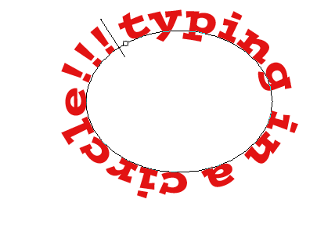
Different types of text, different fonts, even different colors can produce different effects. Different effects produce different meanings.

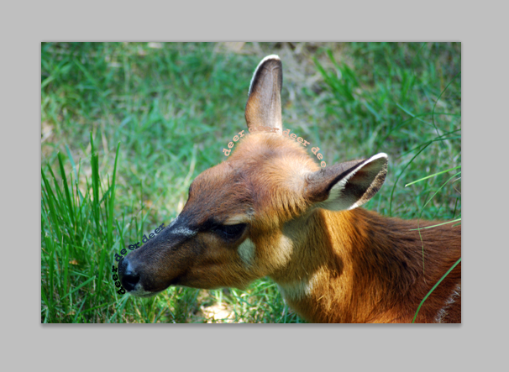
Use the pen tool to trace around an image, and match the color of your text to nearby colors. This will help you to start outlining your image with text.

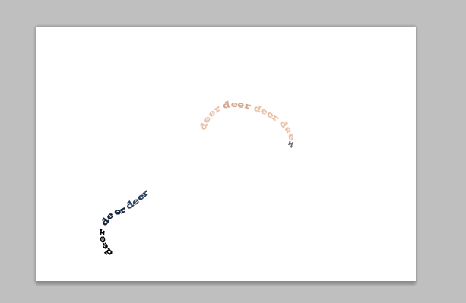
Eventually, you will outline your entire image with text. You can use different effects to make certain parts stand out. After you are done outlining, you will start to fill in your image with text. (When you are filling it in, make the text a lower opacity or do not use text effects in the middle.)

To see examples, go to the O drive> Kids in college > Digital Palette > Projects> Text Art

